Date – 25/12/2015

1. Went to Setting and try to upload the picture. Following error message received.

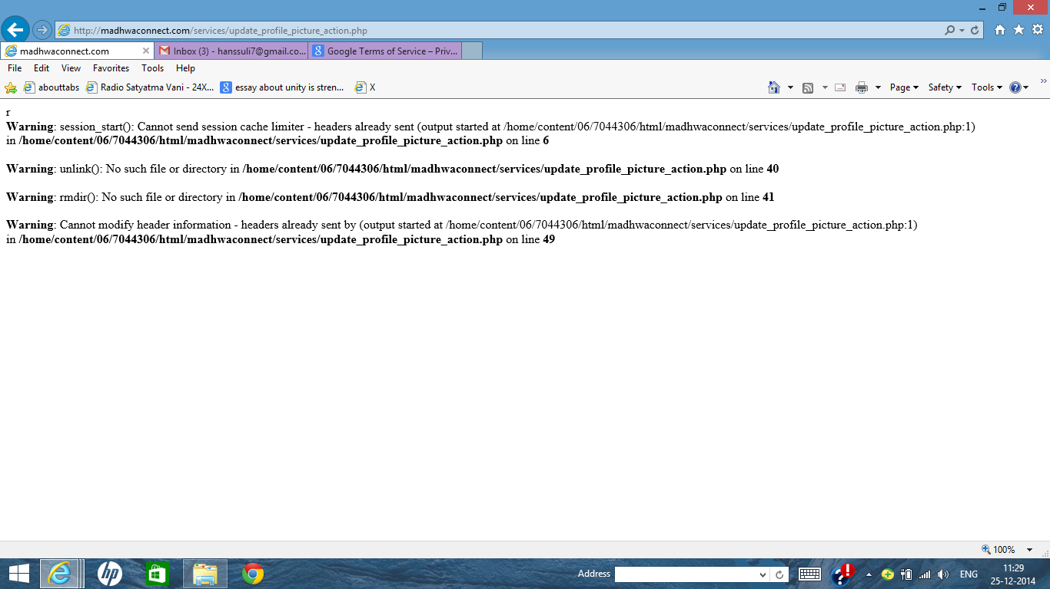

1. Post this step I went to home page and clicked on service tab. After clicking this I see the message showing image is successfully uploaded. Here is the screen shot.

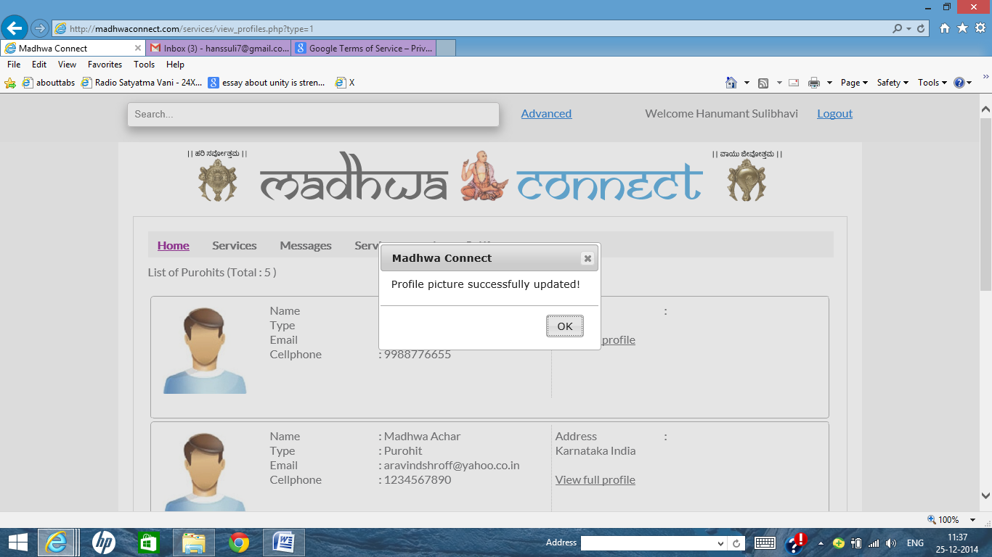

1. If user wants to change his picture, however the system is not taking the second picture. Please validate this functionality
2. For the end user profile – Blocking of dates should not available. Is Calendar helpful for end user in settings?
3. End User/Service Provider where there is no approval –

Thank for registering and your registration details have been accepted. Now you can login and explore Madhwa connect services.

As part of our anti-spam policy, we have sent an mail to your registered email address. You will receive the same in a while. Please check your "Junk Mail" folder also.

Please click the link in the email to update the additional information.

You may close this window now.

1. Service provider where approval is required.

When a new user is created for this type, admin must approve/decline.

Thanks for registering in Madhwa Connect. We are in process of

Madhwa admin will review the complete details and will revert back to you at the earliest by sending you confirmation mail to your registered e-mail id.

As part of our anti-spam policy, we have sent a mail to your registered email address. You will receive the same in a while. Please check your "Junk Mail" folder also.

You may close this window now.

Subject Details for all mails –

**Letter of Approval Service Provider 🡪 Subject Line : Approved – Welcome to Mahdwa Connect**

**Letter of Disapproval for service provider 🡪 Subject Line : Request Declined**

**Users Registration 🡪 Subject Line : Welcome to Mahdwa Connect**

**Service Provider registration mail 🡪 Subject Line : Welcome to Mahdwa Connect**